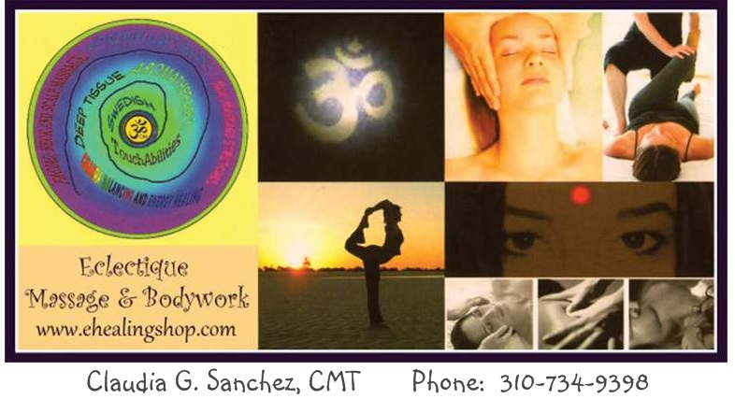

What should I expect after my massage?
After a Massage it is important to drink lots of water. Massage moves metabolites and other cell by-products out of the tissues into the lymph and blood stream. Water flushes these by-products out of the body. Massage helps to maintain the muscles and soft tissue in an optimum state of oxygenation and nutrition by improving the circulation of both blood and lymph.
Massage helps improve flexibility, relaxation and promotes overall muscle balance by reducing tenseness (hyper tonicity). Massage enables recovery from soft tissue injuries like muscle pulls, spasms, and micro trauma by reducing the likelihood of chronic problems and further injury. Specialized therapeutic techniques reduce adhesions and scar tissue formation in soft tissue thus allowing re-establishment of full elongation and contraction of muscles promoting balance and increased range of motion. Massage creates a positive effect both physically and mentally by reducing pain and promoting relaxation. Massage helps to enhance body awareness and makes one aware of patterns of stress and tension.
Extensive deep muscle work may cause some temporary swelling and local tenderness due to the release of lactic acid and other metabolic by-products of cellular metabolism. Application of ice for 5 minutes every few hours will help ease this condition which may persist in some people for a few days. This feeling is very much like the soreness one gets from working out. If this soreness continues or discomfort increases, please call.
When in doubt drink more water. Drinking water is the single most important thing you can do to help your body. Continue to take any medications which your doctor has prescribed. Let your doctor know you have gotten a massage. Also if your doctor has any specific recommendations concerning massage, please let me know.
Enjoy! Your muscles may continue to relax for several hours following your massage.

